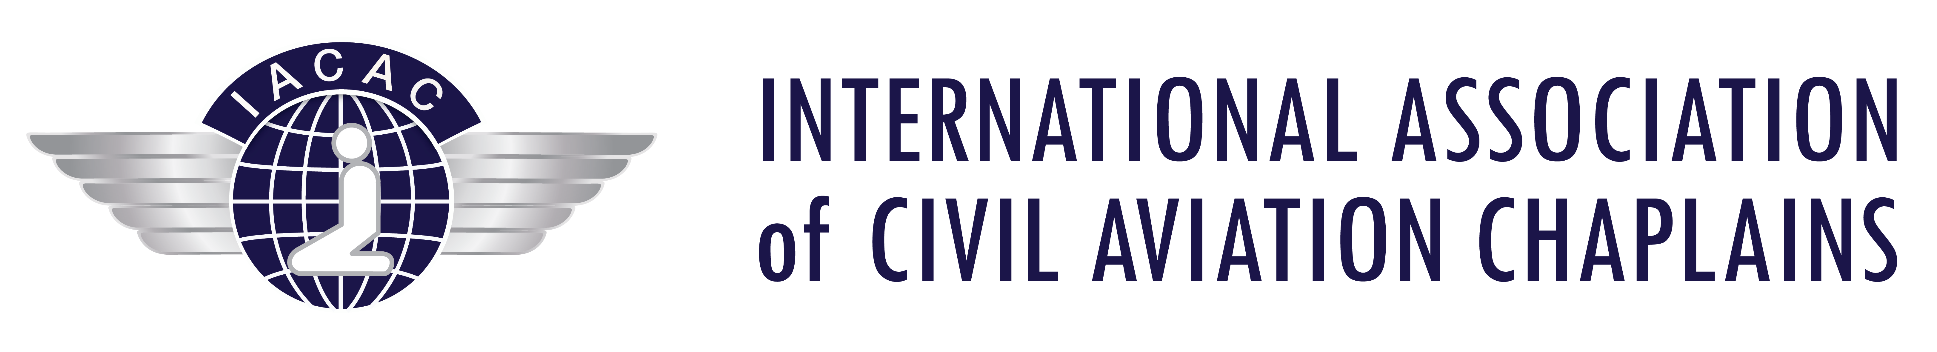
The 55th Annual Conference of the

International Association of Civil Aviation Chaplains
LONDON -UK

from 19TH-23RD SEPTEMBER 2022

SUBSIDY APPLICATION FOR THE CONFERENCE

Section 14 of the Association’s Constitution gives details concerning the payment of Subsidies to members, and is printed below.

You are reminded that a subsidy is only for the Conference Fee. It cannot be for the cost of travel to the Conference, or any of the cost of the Post-Conference Tour. THEREFORE, a member receiving a Subsidy will be ineligible to participate in the Post-Conference Tour unless it can be demonstrated that the cost of the Tour is being provided by a third party.

If you consider you are eligible for a subsidy you must apply on the Subsidy Application Form available from the Secretary, and provide the supporting authority from your Church Leader.

Your request for a Subsidy Application Form must be made before 1ST JULY 2022

The President must receive the application prior to the Conference .

A Subsidy Application Form is available online at www.iacac.aero or by request to the Secretary by E-mail.

Secretary Deacon Jim Martin E-mail secretary@iacac.aero

Extract from the Constitution
14 Subsidy Fund

14.1 The Executive Board has established a Subsidy Fund to assist active members to attend the Annual Conference by contributing towards the cost of the Conference Fee.

14.2 Subsidies cannot be granted to assist with the cost of travel, or towards any of the cost of the Post Conference Tour.

  - In order to ensure fair distribution of the Fund those applying must do so on the Form provided on request from the Secretary, notice of which is sent with each Conference invitation. (A sample of the Form is attached to the Constitution as Appendix 2.)

  - An application must be supported by reference from a senior church person to whom the applicant is responsible within the chaplaincy or faith community, this person endorsing their support with a letter of confirmation.

  - Applications must be submitted to the President before the start of the Annual Conference to allow time for the Board to consider all applications and fair distribution from the Fund.

  - Applications received after the closing date cannot be considered.

  - The names of applicants and the decision of the Board shall be confidential.

  - The Subsidy Fund is available to all active members of the Association, providing that their subscription (dues) is up to date.

  - At the discretion of the Executive Board, consideration may be given to those whose Application for Membership is to be considered at the Annual Business Meeting to be held during that Conference.

  - A Subsidy granted to a member is for that member only and is not transferable.

  - Only one Subsidy may be granted per Chaplaincy, per Country, although if funds are available the Board may, at their discretion, waive this Clause.

  - A person receiving assistance from the Subsidy Fund may not normally receive a Subsidy for two conferences following that for which they received the subsidy, although if funds are available the Board may, at their discretion, waive this Clause.

  - No subsidy shall be granted by the conference hosts without consultation with the Board.

  - If the Board determines that a subsidy has been claimed fradulently or misuded, the applicant will be ineligible for future subsidies.

Taken from the Constitution as amended on the 7 th day of October 2018 as agreed at the Annual Business Meeting held in Charlotte. USA.

Subsidy Application Form

The Executive Board maintains a Subsidy Fund in accordance with Sections 12 and 14 of the Association’s Constitution. The Fund is to assist people to attend the Annual Conference by contributing to the cost of the Conference Fee.

Neither the Subsidy Fund nor the Board can assist with travel costs.

The Board does not have funds to support every application. It is therefore necessary for applicants to submit their requests to the President on this Form by the 1ST JULY 2022 before Conference, so that the Board may consider all requests in the fairest way possible.
All applications are treated with confidence.
The Board’s decision is final and not open to examination.

All details must be supplied and reach the following by email by 1ST JULY 2022
president@iacac.aero

Subsidies are only awarded if the following conditions are satisfied

1 The Applicant is a member of the Association and their subscription (dues) is up to date
2 The application is submitted online using this Form
3 The Applicant has not received a Subsidy for the previous 2 years conferences.
4 A personal letter of support from a Bishop, or equivalent, in the person’s faith group is included.

It will assist your Application if you can pay towards some of the costs

Name

Address/email
Airport
The Conference will cost |  |  | $885 USD Single  $1220 Twin Share/Double  ($610 perperson)
How much are you able to pay yourself?
How much are you asking the Board to provide?
Are you a member? | YES / NO | Year of election to IACAC
Have you received a subsidy before? |  | YES / NO | Year ..........................

YES / NO
Are you willing to share a room with another delegate?

I ask the Board to consider my application for financial assistance ...........................................
signed

I support .................................................. in his/her application, and attach a letter of confirmation.

Signed ......................................................... Position .........................................................

Received by President and Secretary
Discussed with Board members
Decision

